How do I stay safe when I'm driving?
Since the risk zone for driver air bags is the first 2-3 inches of inflation, placing yourself 10 inches from your driver air bag provides you with a clear margin of safety. This distance is measured from the center of the steering wheel to your breastbone. If you now sit less than 10 inches away, you can change your driving position in several ways:
- Move your seat to the rear as far as you can while still reaching the pedals comfortably.
- Slightly recline the back of the seat. Although vehicle designs vary, many drivers can achieve the 10-inch distance, even with the driver seat all the way forward, simply by reclining the back of the seat somewhat. If reclining the back of your seat makes it hard to see the road, raise yourself by using a firm, non-slippery cushion, or raise the seat if your vehicle has that feature.
- If your steering wheel is adjustable, tilt it downward. This points the air bag toward your chest instead of your head and neck.
[In its published version, the brochure will be 10 inches tall and will indicate that it should be placed between your breastbone and the center of the air bag cover to check your distance.]

Wrong  Unbelted and too close | Use Seat Belts
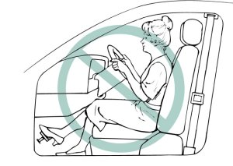 | 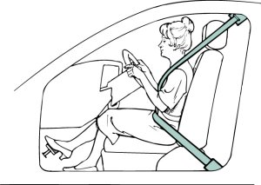
Move Seat Rearward | Recline Back of Seat
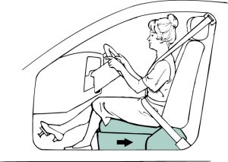 | 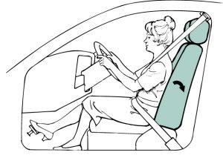
Tilt Wheel Down | Correct  Belted and 10 inches or more away
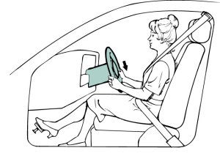 | 